Lab 3 Report | Scope Management

Nguyen Tieu Phuong 20210692

# Result

Results received when executing project with one of given files in folder **test**.

Here I choose **Example 4.kpl** file.

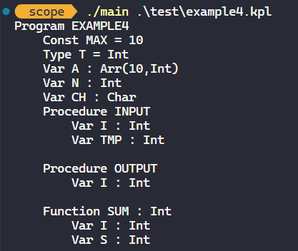

# Errors

All kind​s of errors that can be found by the semantic analyzer, except ERR_UNDECLARED_INT_CONSTANT

### ERR_END_OF_COMMENT

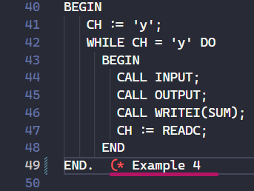 

### ERR_IDENT_TOO_LONG

### ERR_NUMBER_TOO_LONG

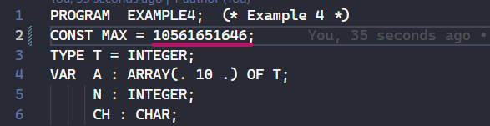 

### ERR_INVALID_CONSTANT_CHAR

### ERR_INVALID_SYMBOL

### ERR_INVALID_CONSTANT

### ERR_INVALID_TYPE

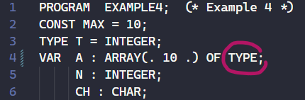 

### ERR_INVALID_BASICTYPE



### ERR_INVALID_PARAMETER

### ERR_INVALID_STATEMENT

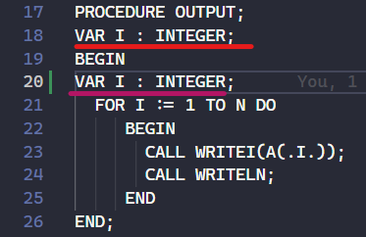 

### ERR_INVALID_TERM

### ERR_INVALID_FACTOR

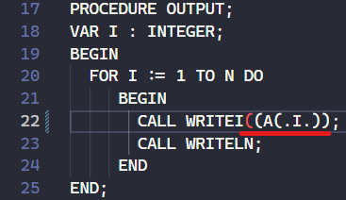 

### ERR_UNDECLARED_IDENT

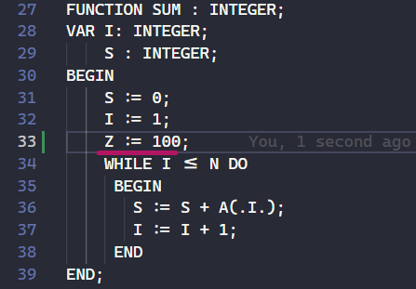 

### ERR_UNDECLARED_TYPE

### ERR_UNDECLARED_VARIABLE

Here I use P, a variable that is never declared.



### ERR_UNDECLARED_PROCEDURE

### ERR_DUPLICATE_IDENT

### ERR_INVALID_ARGUMENTS

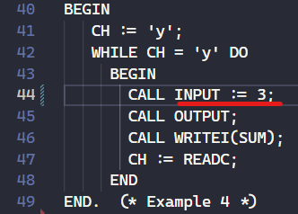

### ERR_INVALID_FUNCTION

This error is not defined in the source code yet.

### ERR_INVALID_PROCEDURE

### ERR_INVALID_IDENT

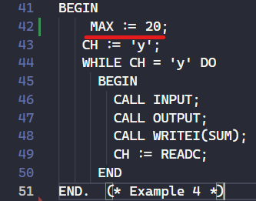 

### ERR_INVALID_RETURN

### ERR_UNDECLARED_CONSTANT

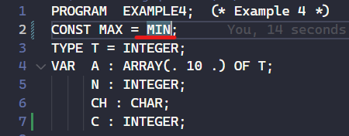

### ERR_INVALID_LVALUE

### ERR_INVALID_VARIABLE

THE END